

**Tribhuvan University**

**Faculty of Humanities and Social Sciences**

**A PROJECT REPORT ON**

A Niche Social Media Platform

**Submitted to**

**Department of Computer Application**

**Ambikeshwari Campus**

***In partial fulfillment of the requirements for the Bachelors in Computer Application***

Submitted by

Manish Bhusal

Roll No:- 112502147

Date of Submission: 2025 March

Under the Supervision of

**Nabraj Basel**



**Tribhuvan University**

**Faculty of Humanities and Social Sciences**

**Ambikeshwari Campus**

**Supervisor’s Recommendation**

I hereby recommend that this project prepared under my supervision by Manish Bhusal entitled “**A Niche Social Media Platform”** in partial fulfillment of the requirements for the degree of Bachelor of Computer Application is recommended for the final evaluation.

------------------

**SIGNATURE**

Mr. Nabraj Basel

**SUPERVISOR**



**Tribhuvan University**

**Faculty of Humanities and Social Sciences**

**Ambikeshwari Campus**

**LETTER OF APPROVAL**

This is to certify that this project prepared by **Manish Bhusal** entitled “**A Niche Social Media Platform”** in partial fulfillment of the requirements for the degree of Bachelor in Computer Application has been evaluated. In our opinion it is satisfactory in the scope and quality as a project for the required degree.

|  |  |
| --- | --- |
| -----------------------  **Supervisor**  Mr. Nabraj Basel  Supervisor  Department of BCA  Ambikeshwari Campus | ----------------------  **HOD**  Mr. Nabraj Basel  Coordinator  Department of BCA  Ambikeshwari Campus |
| ------------------  **Internal Examiner** | -------------------  **External Examiner** |

**Abstract**

This project aims to develop a social media platform, ConnectMe, where users can create, share, and engage with communities centered around common interests. The platform supports core CRUD (Create, Read, Update, Delete) functionalities, enabling users to post content, edit, view, and delete their posts. It provides a structured content management system and ensures a user-friendly interaction experience. ConnectMe also lays the groundwork for future enhancements, including community-based discussions, advanced user engagement features, and personalized dashboards. Git and GitHub were utilized for version control and collaboration, ensuring efficient project management and scalability.

**Keywords:***Social Media Platform, ASP.NET MVC*

**Acknowledgement**

I would like to express my heartfelt gratitude to my supervisor, **Mr. Nabraj Basel**, for his invaluable guidance, continuous support, and insightful suggestions throughout the development of this project, *ConnectMe*. His mentorship has been instrumental in helping me successfully implement this project and deepen my understanding of web development and database management.

I would also like to extend my sincere appreciation to **Ambikeshwari Campus** for providing a supportive learning environment that encouraged me to take on this project. The knowledge and skills I have acquired during my time at the institution have been crucial in shaping this work.

Furthermore, I am thankful to my professors and colleagues for their encouragement, constructive feedback, and discussions, which have significantly contributed to refining this project. Their insights have helped me enhance both the technical and conceptual aspects of *ConnectMe*.

Lastly, I am grateful for the opportunity to work on this project, which has allowed me to apply my knowledge of web technologies and database systems in a practical setting. This experience has been a significant milestone in my journey as a developer, helping me improve my problem-solving skills and technical expertise.

Manish Bhusal

112502147

**Table Of Contents**

Chapter 1: Introduction 7

1.1 Introduction 7

1.2 Problem Statement 7

1.3 Objectives 8

1.4 Scope and limitation 8

1.5 Report Organization 9

Chapter 2: Background Study & Literature Review 10

2.1 Background Study 10

2.2 Literature Review 10

Chapter 3: System Analysis and Design 12

3.1 System Analysis 12

3.2 System Design 12

**3.2.1 Project Schedule** 14

**3.2.2 Process Scheduling(DFD)** 15

**3.2.3 Database Design:** 16

Chapter 4: Implementation and Testing 17

4.1 Implementation 17

**4.1.1 Tools Used** 17

**4.2.1 Test Cases for Unit Testing** 18

Chapter 5: Conclusion and Future Recommendations 19

5.1 Lesson Learnt / Outcome: 19

5.2 Conclusion: 19

5.3 Future Recommendations: 19

References 21

Appendices 22

Screenshots: 22

Source Codes: 24

# Chapter 1: Introduction

## 1.1 Introduction

**ConnectMe** is a social media platform designed to enable users to create and join communities based on shared interests. It provides a space where users can engage through posts, comments, and discussions, fostering meaningful interactions. The platform allows users to post content, edit, read, and delete posts, fulfilling the core **CRUD (Create, Read, Update, Delete)** operations.

The primary goal of **ConnectMe** is to create an organized and interactive space where users can connect with like-minded individuals, share knowledge, and participate in discussions within their communities. The system also ensures that user-generated content remains manageable and structured.

The platform has been developed using **ASP.NET MVC** for the backend, **MSSQL** for database management, and **HTML, CSS, and JavaScript** for the front-end, ensuring a responsive and user-friendly interface. Git and GitHub have been used for version control and collaboration. While the current version primarily focuses on CRUD operations for posts, future enhancements can include additional features like user authentication, community management, and real-time interactions.

## 1.2 Problem Statement

In today's digital era, social media platforms play a significant role in connecting people, yet many existing platforms lack dedicated spaces for structured, topic-based discussions. Users often struggle to find well-organized communities where they can engage in meaningful conversations without distractions.

Additionally, most social media platforms do not provide **simplified content management** for users, leading to issues such as:

* **Lack of dedicated spaces for communities**: Users cannot easily find or create interest-based communities tailored to specific topics.
* **Limited content control**: Many platforms do not allow users to efficiently manage their posts, making it difficult to edit or delete content when needed.
* **Scattered engagement**: Users find it challenging to track discussions and contributions within their communities.

To address these challenges, **ConnectMe** was developed as a **community-driven** platform with structured post management, ensuring users can create, edit, and delete content within their communities seamlessly. It serves as a foundation for building a scalable and user-friendly social media experience while providing a structured environment for discussions.

## 1.3 Objectives

The primary objectives of the **ConnectMe** project are:

* To develop a **social media platform** that enables users to create and join communities based on shared interests.
* To provide a **user-friendly and interactive platform** for discussions, engagement, and content sharing.
* To ensure **structured content management**, making it easy for users to organize and interact with posts within their communities.
* To lay the foundation for **future enhancements**, including user authentication, real-time engagement, and advanced community features.

## Scope and limitation

**Scope**

* **User Engagement**: Users can create, edit, and delete posts within their communities.
* **Community Management**: Users can join and interact within different communities based on their interests.
* **Content Moderation**: Basic content management allows users to maintain relevant discussions.
* **Scalability**: The platform is designed with extendability in mind, allowing additional features to be integrated in the future.

**Limitation**

* **Limited Features**: Currently, the project focuses only on CRUD operations for posts; other features like real-time messaging, notifications, and advanced community moderation are yet to be implemented.
* **No Advanced User Authentication**: The current version does not include advanced security features like multi-factor authentication.
* **No Monetization or Online Payment**: The platform does not support payment systems for premium features or advertisements.
* **Internet Dependency**: Users require an active internet connection to access and interact with the platform.

## Report Organization

The report is structured as follows:

* **Chapter 1**: Introduction – Provides an overview of the ConnectMe project, including the problem statement, objectives, scope, and limitations of the system.
* **Chapter 2**: Background Study – Discusses the concepts and technologies related to social media platforms. It includes a literature review that examines similar systems to compare features and functionalities.
* **Chapter 3**: System Analysis and Design – Covers the system architecture, database schema, and interface design. It includes various diagrams such as use case diagrams, data flow diagrams (DFD), and entity-relationship (ER) diagrams to explain system functionality.
* **Chapter 4**: Implementation and Testing – Details the tools, technologies, and frameworks used in the project. It also explains the project implementation process, including algorithms and test cases used to validate system performance.
* **Chapter 5**: Conclusion and Future Enhancements – Summarizes the lessons learned throughout the development of the ConnectMe platform. It provides recommendations for future improvements, including potential features like real-time messaging, user authentication, and enhanced community interactions.

## 

# Chapter 2: Background Study & Literature Review

## 2.1 Background Study

The **ConnectMe** platform is designed to provide users with an interactive social media experience where they can create and join communities, share posts, and engage in discussions. The idea of this project originated from the limitations of traditional online forums and the need for a structured yet engaging platform where users can connect based on shared interests.

In traditional social media and online communities, some common issues arise:

* **Lack of personalization:** Users often face difficulty finding relevant content that aligns with their interests.
* **Limited control over content visibility:** Many platforms prioritize engagement-driven algorithms rather than community-driven content.
* **No dedicated communities for niche topics:** While larger platforms like Facebook and Reddit allow for communities, many users find them either too broad or too cluttered with unrelated content.
* **Poor content management:** Posts often get buried under new content, making it hard to track past discussions.

**ConnectMe** aims to solve these problems by allowing users to create and manage focused communities, ensuring a personalized and structured interaction within interest-based groups.

## 2.2 Literature Review

The development of **ConnectMe** is influenced by various existing social networking and online community models. The evolution of social media platforms has shown a shift from general-purpose networks to community-driven interactions.

**Social Media and Community Models**

1. **Early Online Communities:** Early platforms such as forums, bulletin boards, and Usenet enabled users to connect over shared interests. However, these systems lacked the interactivity, real-time updates, and engagement features prevalent in today’s platforms [1].
2. **Rise of Modern Social Media**  
   Platforms like Facebook, Twitter, and Reddit have transformed online interaction by integrating social networking with algorithm-driven content visibility. These systems use sophisticated algorithms to curate content, fostering dynamic and real-time user engagement [2].
3. **Niche Community Platforms**  
   Websites such as Discord and Reddit Communities cater to specific interests, offering interaction models where users can join and contribute to targeted discussions [3]. This focus on niche communities inspires ConnectMe’s design, which aims to support interest-based groups within a broader social framework.

**Technology Trends in Social Media Development**

* **Personalized Feeds:** Modern platforms leverage AI-driven recommendation systems to curate content based on user activity and preferences, enhancing personalization and engagement [4]. ConnectMe adopts this trend to provide tailored experiences while balancing community interaction.
* **Data Security and Privacy:** Amid growing concerns over data privacy, social media platforms increasingly implement user authentication and access controls to ensure secure interactions [5].
* **Decentralized Communities:** In contrast to algorithm-driven visibility, decentralized platforms prioritize user-driven discussions, ensuring content remains relevant and accessible without centralized control [6].

By analyzing existing social media structures, ConnectMe is built as a hybrid solution that bridges the gap between traditional forums and algorithm-driven platforms, providing a community-focused, personalized user experience.

# Chapter 3: System Analysis and Design

## 3.1 System Analysis

It is a process of collecting and interpreting facts, identifying the problems, and decomposition of a system into its components.

System analysis is conducted for the purpose of studying a system or its parts in order to identify its objectives. It is a problem-solving technique that improves the system and ensures that all the components of the system work efficiently to accomplish their purpose.

The system will be analyzed based on user needs, focusing on creating a platform that is intuitive, secure, and easily scalable. The analysis will include:

* 1. **User Requirements:** Understanding the needs of users seeking niche communities.
  2. **Functional Requirements**: Defining CRUD operations, user authentication, and community management.
  3. **Non-Functional Requirements**: Ensuring the platform is secure, responsive, and user-friendly.

## 3.2 System Design

The system design will involve:

* **Frontend:** Developed using HTML, CSS, and JavaScript, providing the necessary UI components for user authentication, community management, and user interaction.
* **Backend:** Built with ASP.NET MVC, handling CRUD operations for the post feature, API requests, and business logic.
* **Database:** Implemented using MSSQL, managed through Entity Framework, supporting CRUD operations for posts and user data management.

Fig: System Design of ConnectMe

### **3.2.1 Project Schedule**

The tentative time schedule to accomplish this project along with task are as shown in the figure below:

**Gantt Chart:**

**Fig: Gantt Chart Graph**

### **3.2.2 Process Scheduling(DFD)**

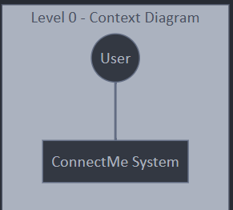

Fig: Context Diagram of ConnectMe

The context diagram showing the user interacting with the ConnectMe system.

Fig: Level 1 DFD of ConnectMe

### **3.2.3 Database Design:**

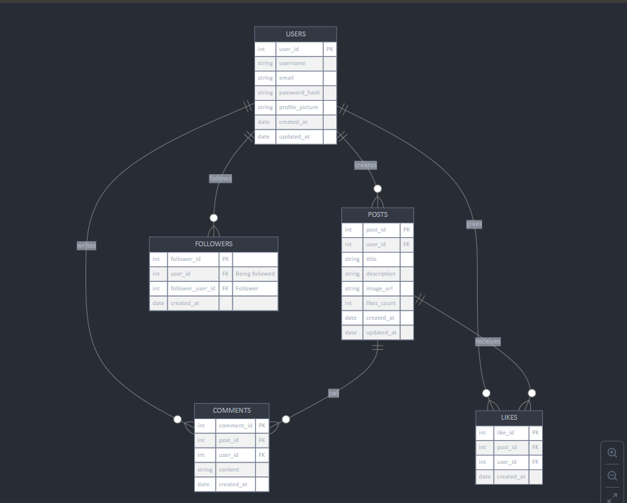

Fig: Database Schema Design of ConnectMe

# Chapter 4: Implementation and Testing

## 4.1 Implementation

### **4.1.1 Tools Used**

**Frontend Tool:**

The frontend of the ConnectMe application is designed using HTML, CSS, JavaScript, and Bootstrap. These technologies provide the structure, styling, and interactivity of the application. Bootstrap, a popular CSS framework, is used for creating a responsive, mobile-first interface. It includes pre-designed components and layouts that allow for the efficient development of web pages and web apps. The use of Bootstrap ensures that the application is user-friendly and works seamlessly on both desktops and mobile devices.

**Backend and Database Tool:**

The backend of ConnectMe is built using **ASP.NET MVC**, a powerful framework for developing dynamic, data-driven websites. ASP.NET MVC handles the business logic, API requests, and CRUD operations for posts and user data. The database is managed using **MSSQL**, a robust relational database management system. The application interacts with MSSQL through **Entity Framework**, which simplifies database operations by mapping database tables to objects in the application.

The **Git** version control system is used to manage and track changes in the project codebase, enabling collaboration and ensuring version control throughout the development process.

**Software Used**

* **Visual Studio** is used as the primary Integrated Development Environment (IDE) for writing and debugging the application’s code.
* **GitHub** is used for version control and collaborative development, ensuring code integrity and easy access to the project files.
* **MSSQL Server Management Studio** is used for managing the database and performing administrative tasks.

The development of ConnectMe makes use of these popular, reliable technologies, ensuring that both the frontend and backend are implemented effectively for an optimal user experience.

### **4.2.1 Test Cases for Unit Testing**

**Table: Test Case for Post Model CRUD Operations**

| **S.N** | **Input Test Data** | **Expected Result** | **Actual Result** | **Remarks** |
| --- | --- | --- | --- | --- |
| 1 | Title: "Test Post", Description: "This is a test post", Image: [No Image] | Post is created successfully with title and description, no image | Post created with title and description, image field remains empty | Pass |
| 2 | Title: "Sample Post", Description: "This is a sample description", Image: [Image File] | Post is created successfully with title, description, and image | Post created with title, description, and image displayed correctly | Pass |
| 3 | Title: "", Description: "Description only", Image: [No Image] | Post creation should fail due to missing title | Error displayed: "Title is required" | Pass |
| 4 | Title: "Valid Title", Description: "", Image: [No Image] | Post created successfully with title, empty description, and no image | Post created with title only, description field is empty | Pass |
| 5 | Title: "Another Post", Description: "Post with an image", Image: [Invalid Image File] | Image upload fails due to invalid file format | Error displayed: "Invalid image file format" | Pass |
| 6 | Title: "Updated Post", Description: "Updated description", Image: [Updated Image] | Post is updated successfully with new title, description, and image | Post updated with new content, image successfully updated | Pass |
| 7 | Title: "Post to be deleted", Description: "Content for deletion", Image: [No Image] | Post is deleted successfully | Post removed from database, no record found | Pass |

# Chapter 5: Conclusion and Future Recommendations

## 5.1 Lesson Learnt / Outcome:

The primary objective of this project was to create a functional social media platform that allows users to create and manage posts within communities. This included the ability to interact with the database to display, edit, and delete content. The most important lesson learned was the management of time, understanding the complexity of different system components, and prioritizing tasks accordingly. A software developer must always conduct thorough research in their daily work, focusing on efficiency and choosing the most effective solutions for each problem. This project emphasized the importance of choosing the right technologies and components for efficient development and functionality.

## 5.2 Conclusion:

Completing this project has been a fulfilling experience, providing both challenges and learning opportunities. The ConnectMe platform was developed to meet the needs of users who wish to engage with others in shared-interest communities. The application was designed using **HTML**, **CSS**, **JavaScript**, **ASP.NET MVC**, and **MSSQL**.

The development of this project taught valuable skills in system analysis and design, such as using interface diagrams to design user-friendly systems, understanding database handling with Entity Framework, and designing applications that prioritize user experience by hiding technical complexities. The project has reinforced the significance of making applications intuitive and accessible for users, ensuring a smooth and seamless experience.

## 5.3 Future Recommendations:

The long-term success of *ConnectMe* will depend on continuous improvements driven by user engagement and feedback. One of the key areas for future enhancement is advanced user management, where role-based access control (RBAC) can be introduced to allow administrators and moderators to manage communities more effectively. Additionally, improving user interaction by integrating features such as comment filtering, content ranking algorithms, and engagement metrics will help foster meaningful discussions and increase participation.

To ensure scalability, optimizing the database architecture through indexing strategies and cloud-based solutions will be crucial in handling increased user activity efficiently. Administrative controls will also be expanded to provide detailed analytics on user behavior, content trends, and community engagement, enabling better decision-making for platform improvements. Another essential feature to consider is real-time functionality, where push notifications and live updates for posts, comments, and direct messaging will enhance the user experience and retention.

Finally, expanding *ConnectMe* into a mobile application will improve accessibility for a broader audience, making the platform more versatile across different devices. By incorporating these improvements, *ConnectMe* can evolve into a more dynamic, scalable, and user-centric platform, ensuring long-term sustainability and engagement.

# References

[1] B. I. Davidson, S. L. Jones, A. N. Joinson, and J. Hinds, "The evolution of online ideological communities," 5, May 2019. [Online]. Available: [**https://journals.plos.org/plosone/article?id=10.1371/journal.pone.0216932**](https://journals.plos.org/plosone/article?id=10.1371/journal.pone.0216932).

[2] A. Gausen, W. Luk, and C. Guo, "Using agent-based modelling to evaluate the impact of algorithmic curation on social media," *ACM Journal of Data and Information Quality*. 1–24, Dec. 2022. [Online]. Available: [**https://dl.acm.org/doi/abs/10.1145/3546915**](https://dl.acm.org/doi/abs/10.1145/3546915).

[3] J. W. P. Miranda, D. H. R. Bueno, and R. C. G. De Souza, "A qualitative approach to develop niche social networks," in *Proc. Int. Conf. Social Networks*, 2016. [Online]. Available: [**https://d1wqtxts1xzle7.cloudfront.net/90537019/237961d22db25238afc19193227e40b56584-libre.pdf**](https://d1wqtxts1xzle7.cloudfront.net/90537019/237961d22db25238afc19193227e40b56584-libre.pdf).

[4] M. N. O. Sadiku, T. J. Ashaolu, and A. Ajayi-Majebi, "Artificial intelligence in social media," *International Journal of Scientific and Engineering Research*. 15–20, 2021. [Online]. Available: [**https://www.ijscia.com/wp-content/uploads/2021/01/Volume2-Issue1-Jan-Feb-No.36-15-20.pdf**](https://www.ijscia.com/wp-content/uploads/2021/01/Volume2-Issue1-Jan-Feb-No.36-15-20.pdf).

[5] A. Praveena and S. Smys, "Anonymization in social networks: A survey on the issues of data privacy in social network sites," *Journal of International Journal Of Engineering And Technology*. 2016. [Online]. Available: [**https://jit.ac.in/journal/cse/75.pdf**](https://jit.ac.in/journal/cse/75.pdf).

[6] B. Guidi and A. Michienzi, "The decentralization of social media through blockchain technology," in *Companion publication of the 13th ACM Web Conference*, 2021. [Online]. Available: [**https://dl.acm.org/doi/abs/10.1145/3462741.3466680**](https://dl.acm.org/doi/abs/10.1145/3462741.3466680).

# Appendices

## Screenshots:

This is the home page. Once users log in, they are taken directly to the feed section.

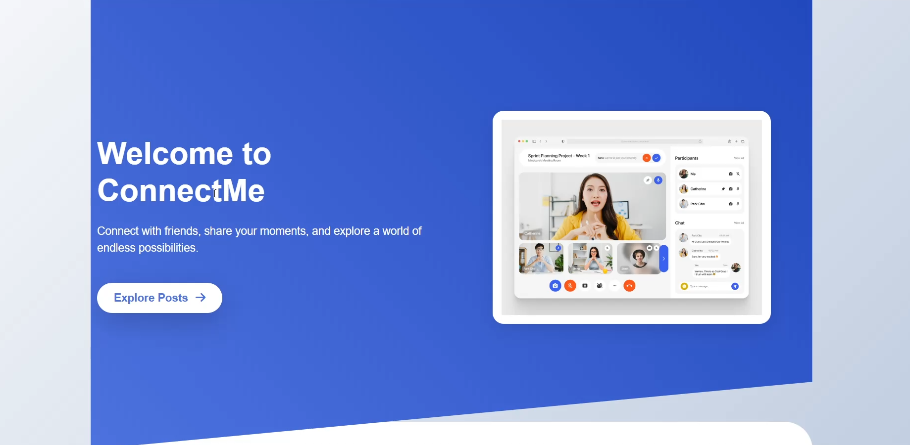

This is where users can see posts shared by others. They can like, comment, and share the posts they see here.

This section allows users to share their own content with others.

This is where everything is stored. All the content uploaded by users is saved in a Microsoft SQL database.

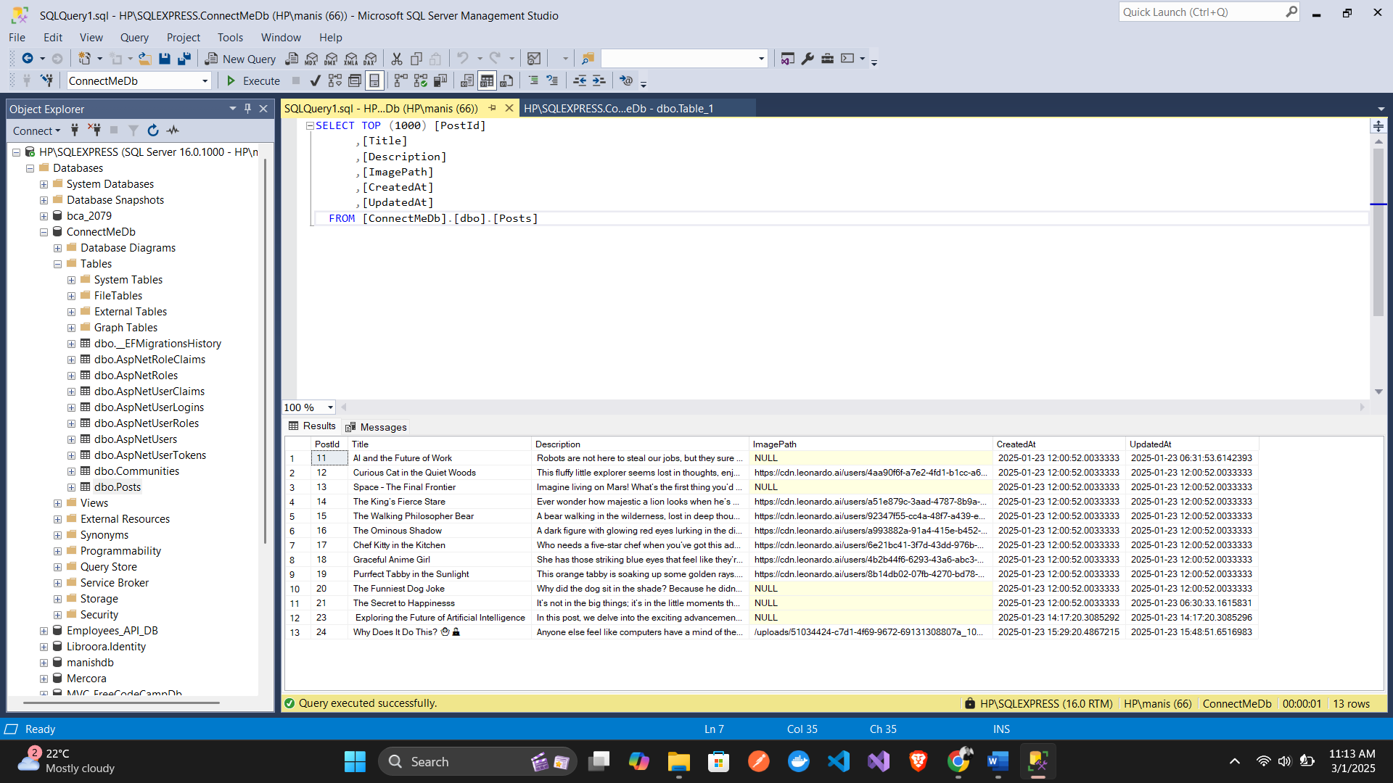

## Source Codes:

*Views/Home/Index.cshtml*

﻿@{

ViewData["Title"] = "Home Page";

}

<div class="hero-section">

<div class="hero-background"></div>

<div class="container">

<div class="row align-items-center flex-column flex-lg-row">

<div class="col-12 col-lg-6 hero-content text-center text-lg-start">

<h1 class="display-4 fw-bold mb-4">Welcome to ConnectMe</h1>

<p class="lead mb-5">

Connect with friends, share your moments, and explore a world of endless possibilities.

</p>

<a href="/Posts" class="btn btn-explore btn-lg shadow-lg">

Explore Posts <i class="fas fa-arrow-right ms-2"></i>

</a>

</div>

<div class="col-12 col-lg-6 text-center mockup-devices mt-5 mt-lg-0">

<div class="device p-3 mb-4">

<img src="https://cdn.dribbble.com/userupload/7927098/file/original-d9af8e07cda22cd396da120d2a69c25f.png?resize=3200x2400" class="img-fluid" alt="ConnectMe Mockup">

</div>

</div>

</div>

</div>

</div>

<div class="features">

<div class="container">

<div class="row text-center g-4">

<div class="col-12 col-md-4 mb-4 mb-md-0">

<div class="feature-card">

<i class="fas fa-users feature-icon"></i>

<h3>Connect</h3>

<p>Build meaningful connections with people who share your interests.</p>

</div>

</div>

<div class="col-12 col-md-4 mb-4 mb-md-0">

<div class="feature-card">

<i class="fas fa-share-alt feature-icon"></i>

<h3>Share</h3>

<p>Express yourself freely through posts, photos, and stories.</p>

</div>

</div>

<div class="col-12 col-md-4">

<div class="feature-card">

<i class="fas fa-globe feature-icon"></i>

<h3>Explore</h3>

<p>Discover new perspectives and expand your digital horizons.</p>

</div>

</div>

</div>

</div>

</div>

*Program.cs:*

using backend.Context;

using Microsoft.EntityFrameworkCore;

namespace ConnectMe.MVC

{

public class Program

{

public static void Main(string[] args)

{

var builder = WebApplication.CreateBuilder(args);

// Add services to the container.

builder.Services.AddControllersWithViews();

// Configuring Entity Framework to use SQL Server

builder.Services.AddDbContext<ApplicationDbContext>(

options => options.UseSqlServer(builder.Configuration.GetConnectionString("SQLAuthConnection"))

);

var app = builder.Build();

// Configure the HTTP request pipeline.

if (!app.Environment.IsDevelopment())

{

app.UseExceptionHandler("/Home/Error");

// The default HSTS value is 30 days. You may want to change this for production scenarios, see https://aka.ms/aspnetcore-hsts.

app.UseHsts();

}

app.UseHttpsRedirection();

app.UseRouting();

app.UseAuthorization();

app.MapStaticAssets();

app.MapControllerRoute(

name: "default",

pattern: "{controller=Home}/{action=Index}/{id?}")

.WithStaticAssets();

app.Run();

}

}

}